Install google authenticator  
sudo apt install libpam-google-authenticator

Run Prompt Configuration  
google-authenticator  
yes  
yes  
Save scratch codes and secret key, also download google authenticator app in any other device such as mobile, open, click and and scan prompt QR code to configure google authentication and follow steps.

**1)Edit pam configuration for require authentication for SSH.**  
sudo nano /etc/pam.d/sshd  
At the bottom of the file add line below  
auth required pam_google_authenticator.so  
now edit SSH configuration file  
sudo nano /etc/ssh/sshd_config  
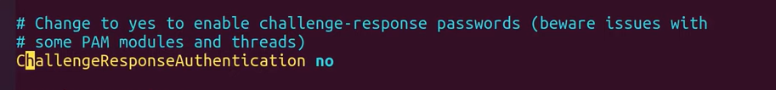

Replace above “no” after challengeResposeauthentication to “yes”

Now service service restart  
sudo service sshd restart  
Test to SSH you should be prompted to provide authentication code.  
  
**2)Edit another configuration for require authentication for Console.**

sudo nano /etc/pam.d/common-seesion  
At the bottom of the file add line below  
auth required pam_google_authenticator.so nullok  
  
**2)Edit another configuration for require authentication for Console and sudo.**

sudo nano /etc/pam.d/common-auth  
At the bottom of the file add line below  
auth required pam_google_authenticator.so nullok